Changing diel growth symmetries and light-capture in PhycoCyanin and PhycoErythrin-rich picocyanobacteria, across photic regimes and growth phases

Sylwia Śliwińska-Wilczewska1,2, Marta Konik3,4, Mireille Savoie1, Naaman Omar1, and Douglas A. Campbell1,✉

1 Department of Biology, Mount Allison University, 53 York St., Sackville NB, Canada, E4L 1C9  
2 Institute of Oceanography, University of Gdansk, 46 Pilsudskiego St, P81-378, Gdynia, Poland  
3 Department of Geography, University of Victoria, Victoria, BC V8P 5C2, Canada  
4 Institute of Oceanology, Polish Academy of Sciences, 81-712 Sopot, Poland

✉ Correspondence: [Douglas A. Campbell <[dcampbel@mta.ca](mailto:dcampbel@mta.ca)>](mailto:dcampbel@mta.ca)

# Supplementary material

COMMENT: /as supplemental data show the plots of deltaOD vs elapsed time with the overlaid logistic fits.

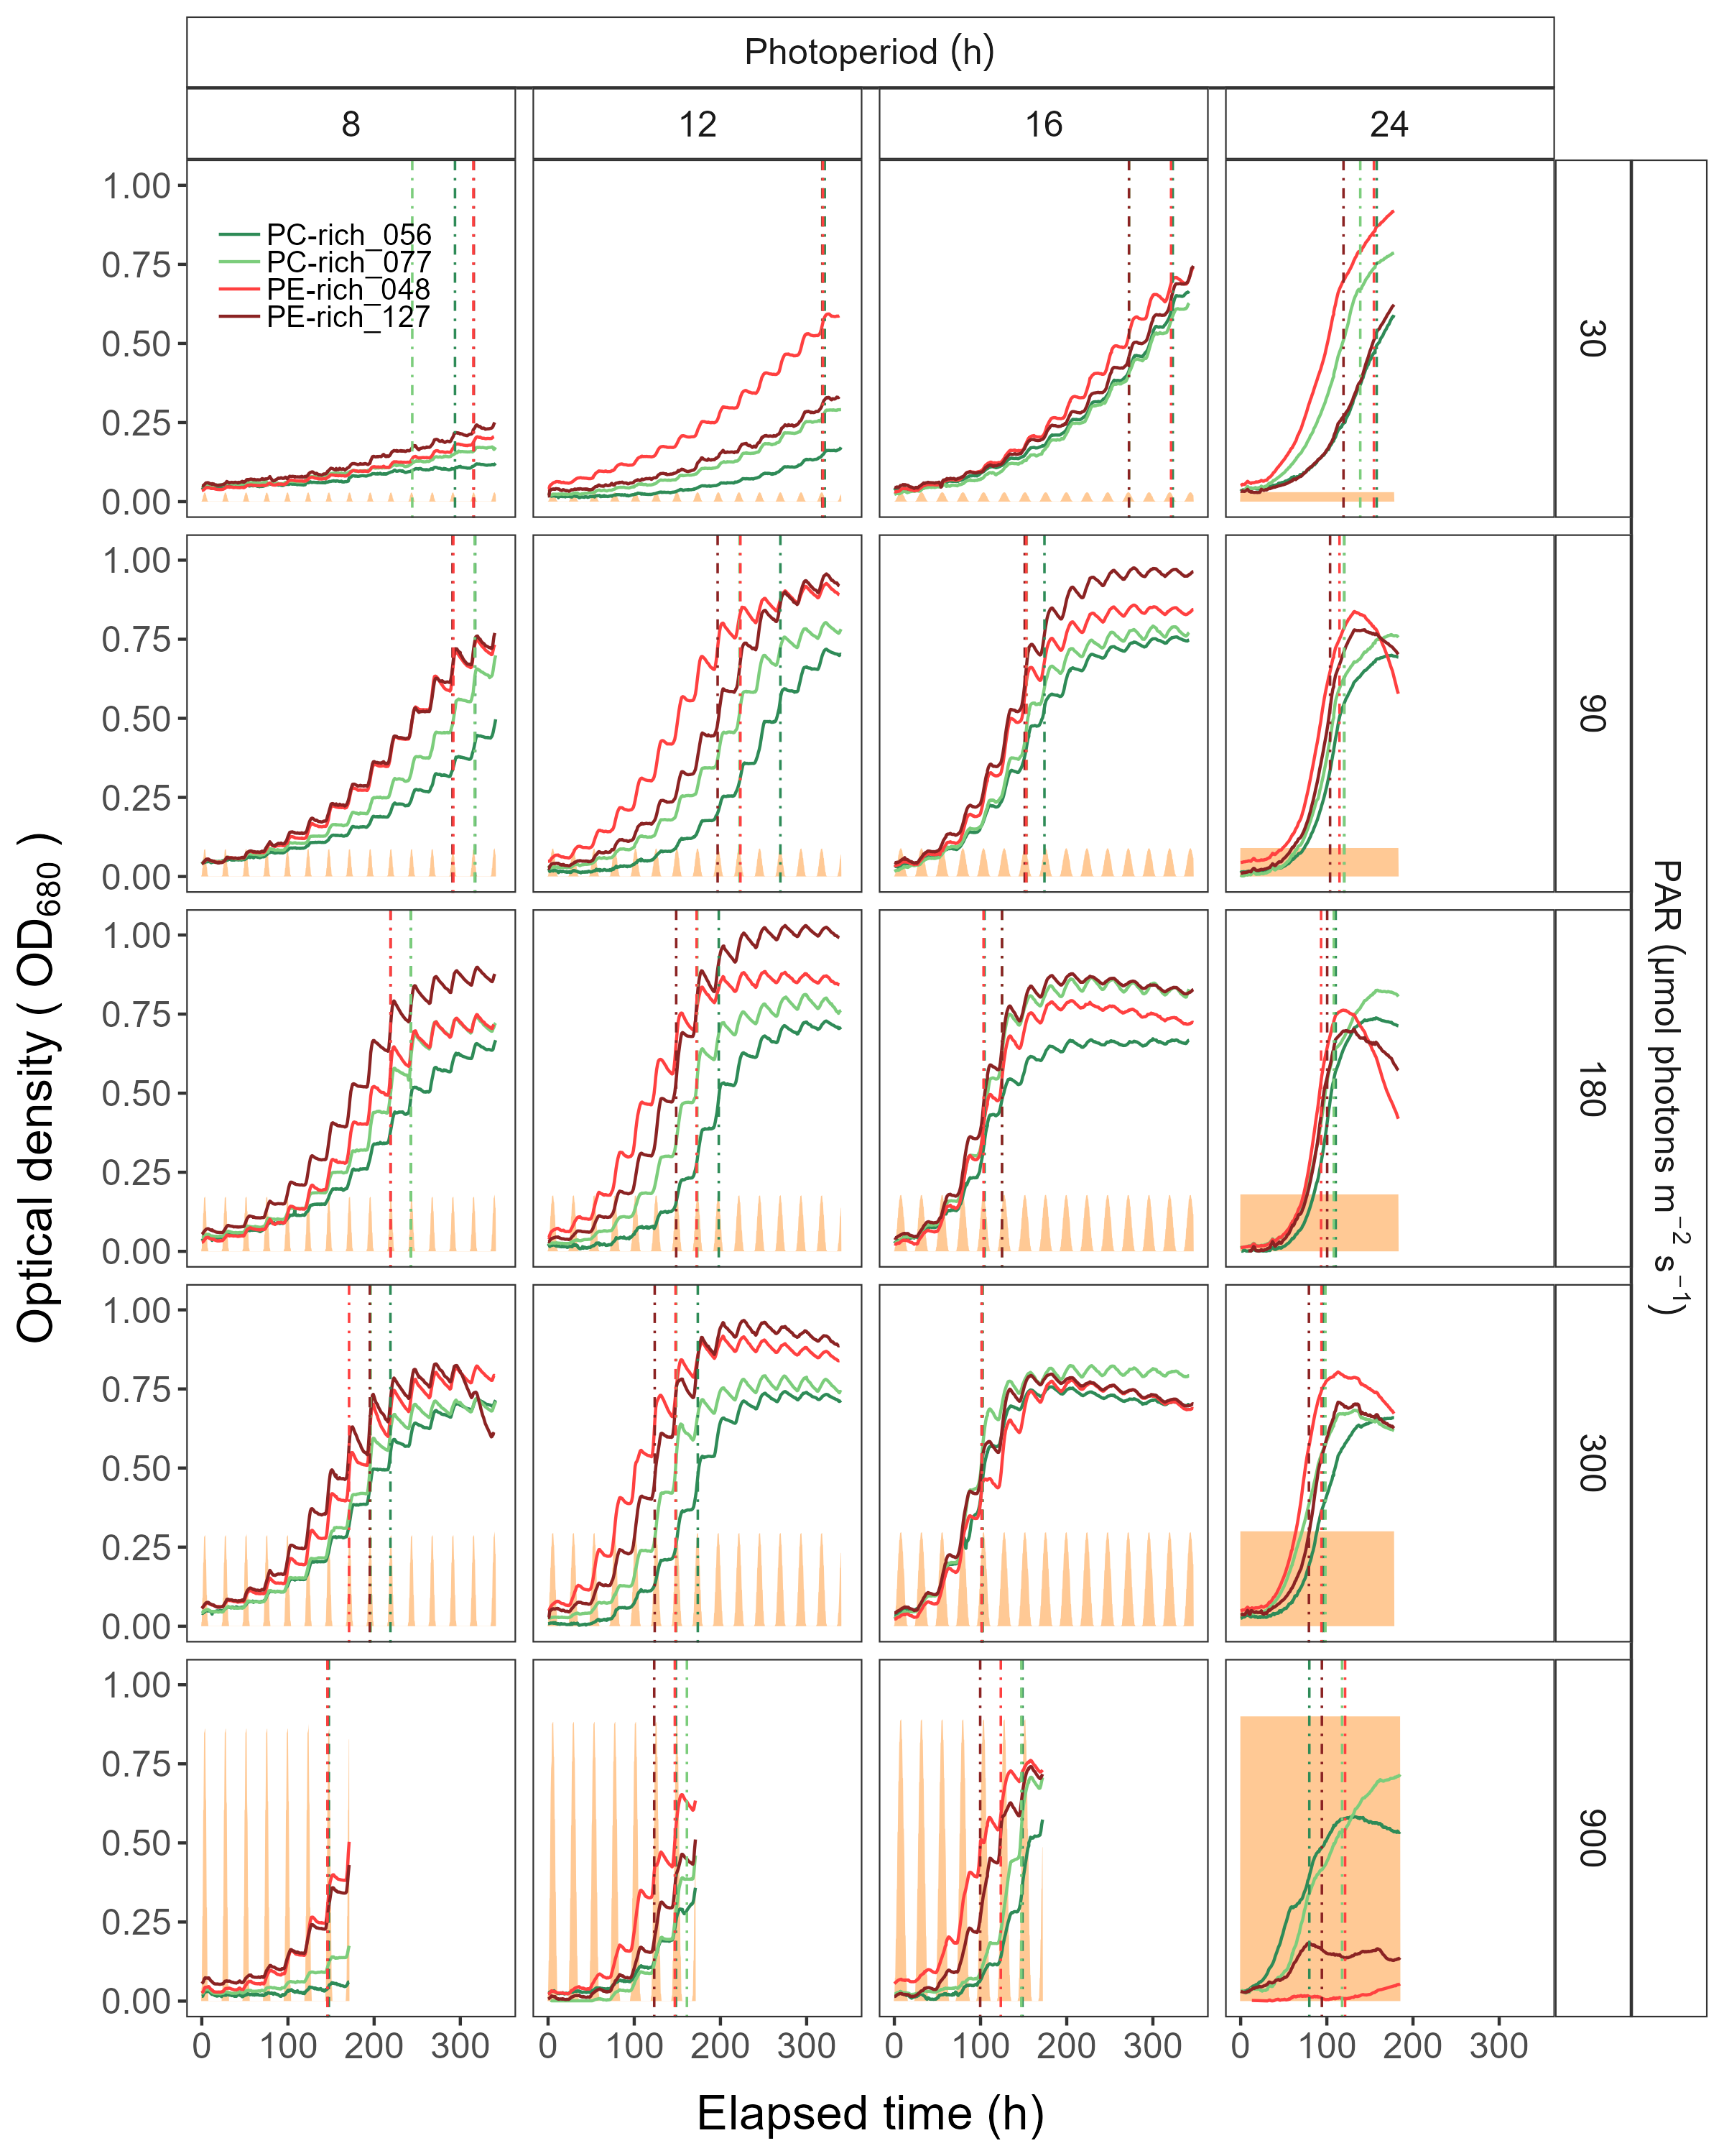

Figure 1: Example of representative growth curves (tracked as OD680) of two PhycoCyanin(PC)-rich cultures (light green line; 056, dark green line; 077) and two PhycoErythrin(PE)-rich cultures (light red line; 048, dark red line; 127) (Culture Collection of Baltic Algae) of *Synechococcus* sp. grown at 30, 90, 180, 300, or 900 peak PAR µmol photons m−2s−1; and photoperiods of 8, 12, 16, or 24 h. The vertical lines represent the time when the cultures reached their maximum absolute hourly growth (tMaxAG), taken as an index of transition from exponential to pre-stationary growth phases. The orange area represents the photoperiods, with peak PAR x 1/1000 to scale to the Y axis.

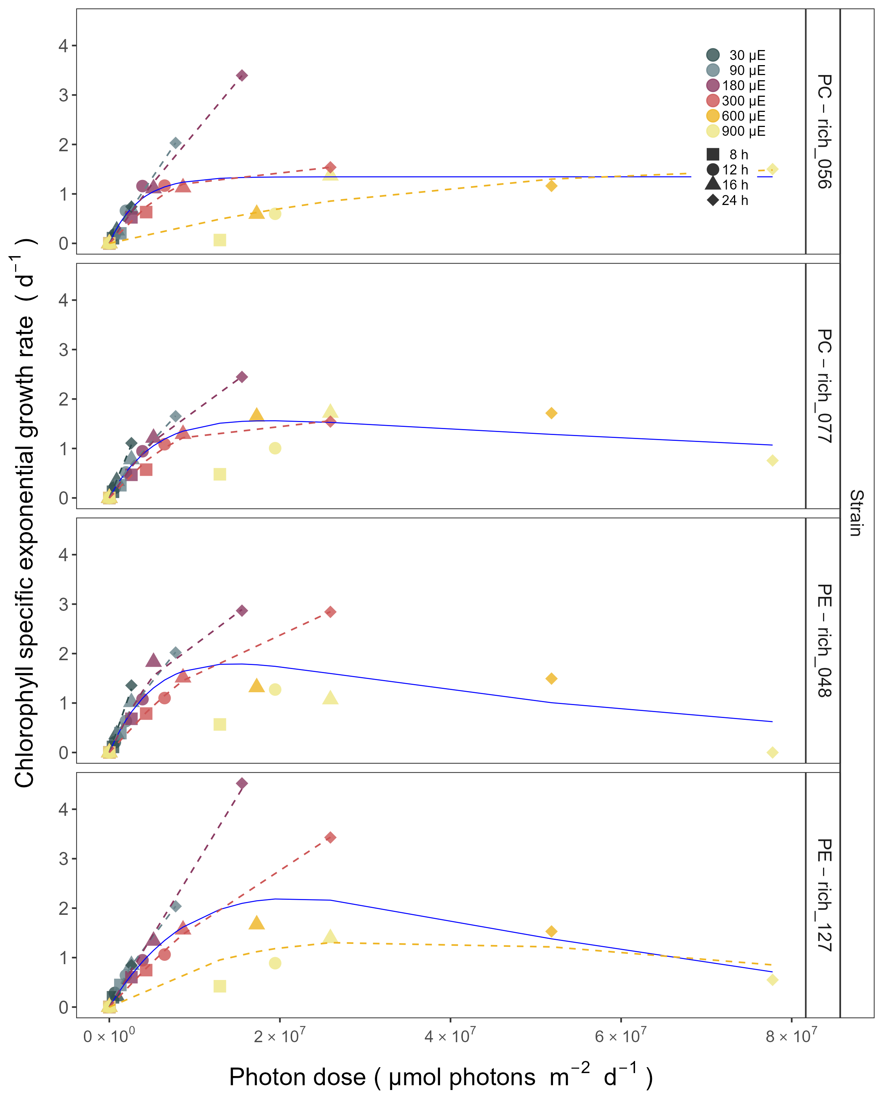

Figure 2: Chlorophyll specific exponential growth rates, estimated from logistic fits of chlorophyll proxy OD680-OD720 vs. elapsed time, for two PhycoCyanin(PC)-rich cultures (056, 077) and two PhycoErythrin(PE)-rich cultures (048, 127) (Culture Collection of Baltic Algae) of *Synechococcus* sp. grown at 30, 90, 180, 300, 600, or 900 peak PAR µmol photons m−2s−1; and photoperiods of 8, 12, 16, or 24 h. Growth rates (+/- SE from logistic model; SE falls within symbol sizes) are plotted vs. cumulative diel µmol photons m−2d−1. Solid blue line shows fit of the pooled data with a three parameter model (Harrison and Platt, 1986). We also fit separate lines for growth under 30 (dark gray line), 90 (light gray line), 180 (purple line), 300 (red line), 600 together with 900 (orange line) peak PAR µmol photons m−2s−1, only when they were significantly different (ANOVA, *p* < 0.05) from the pooled fit.

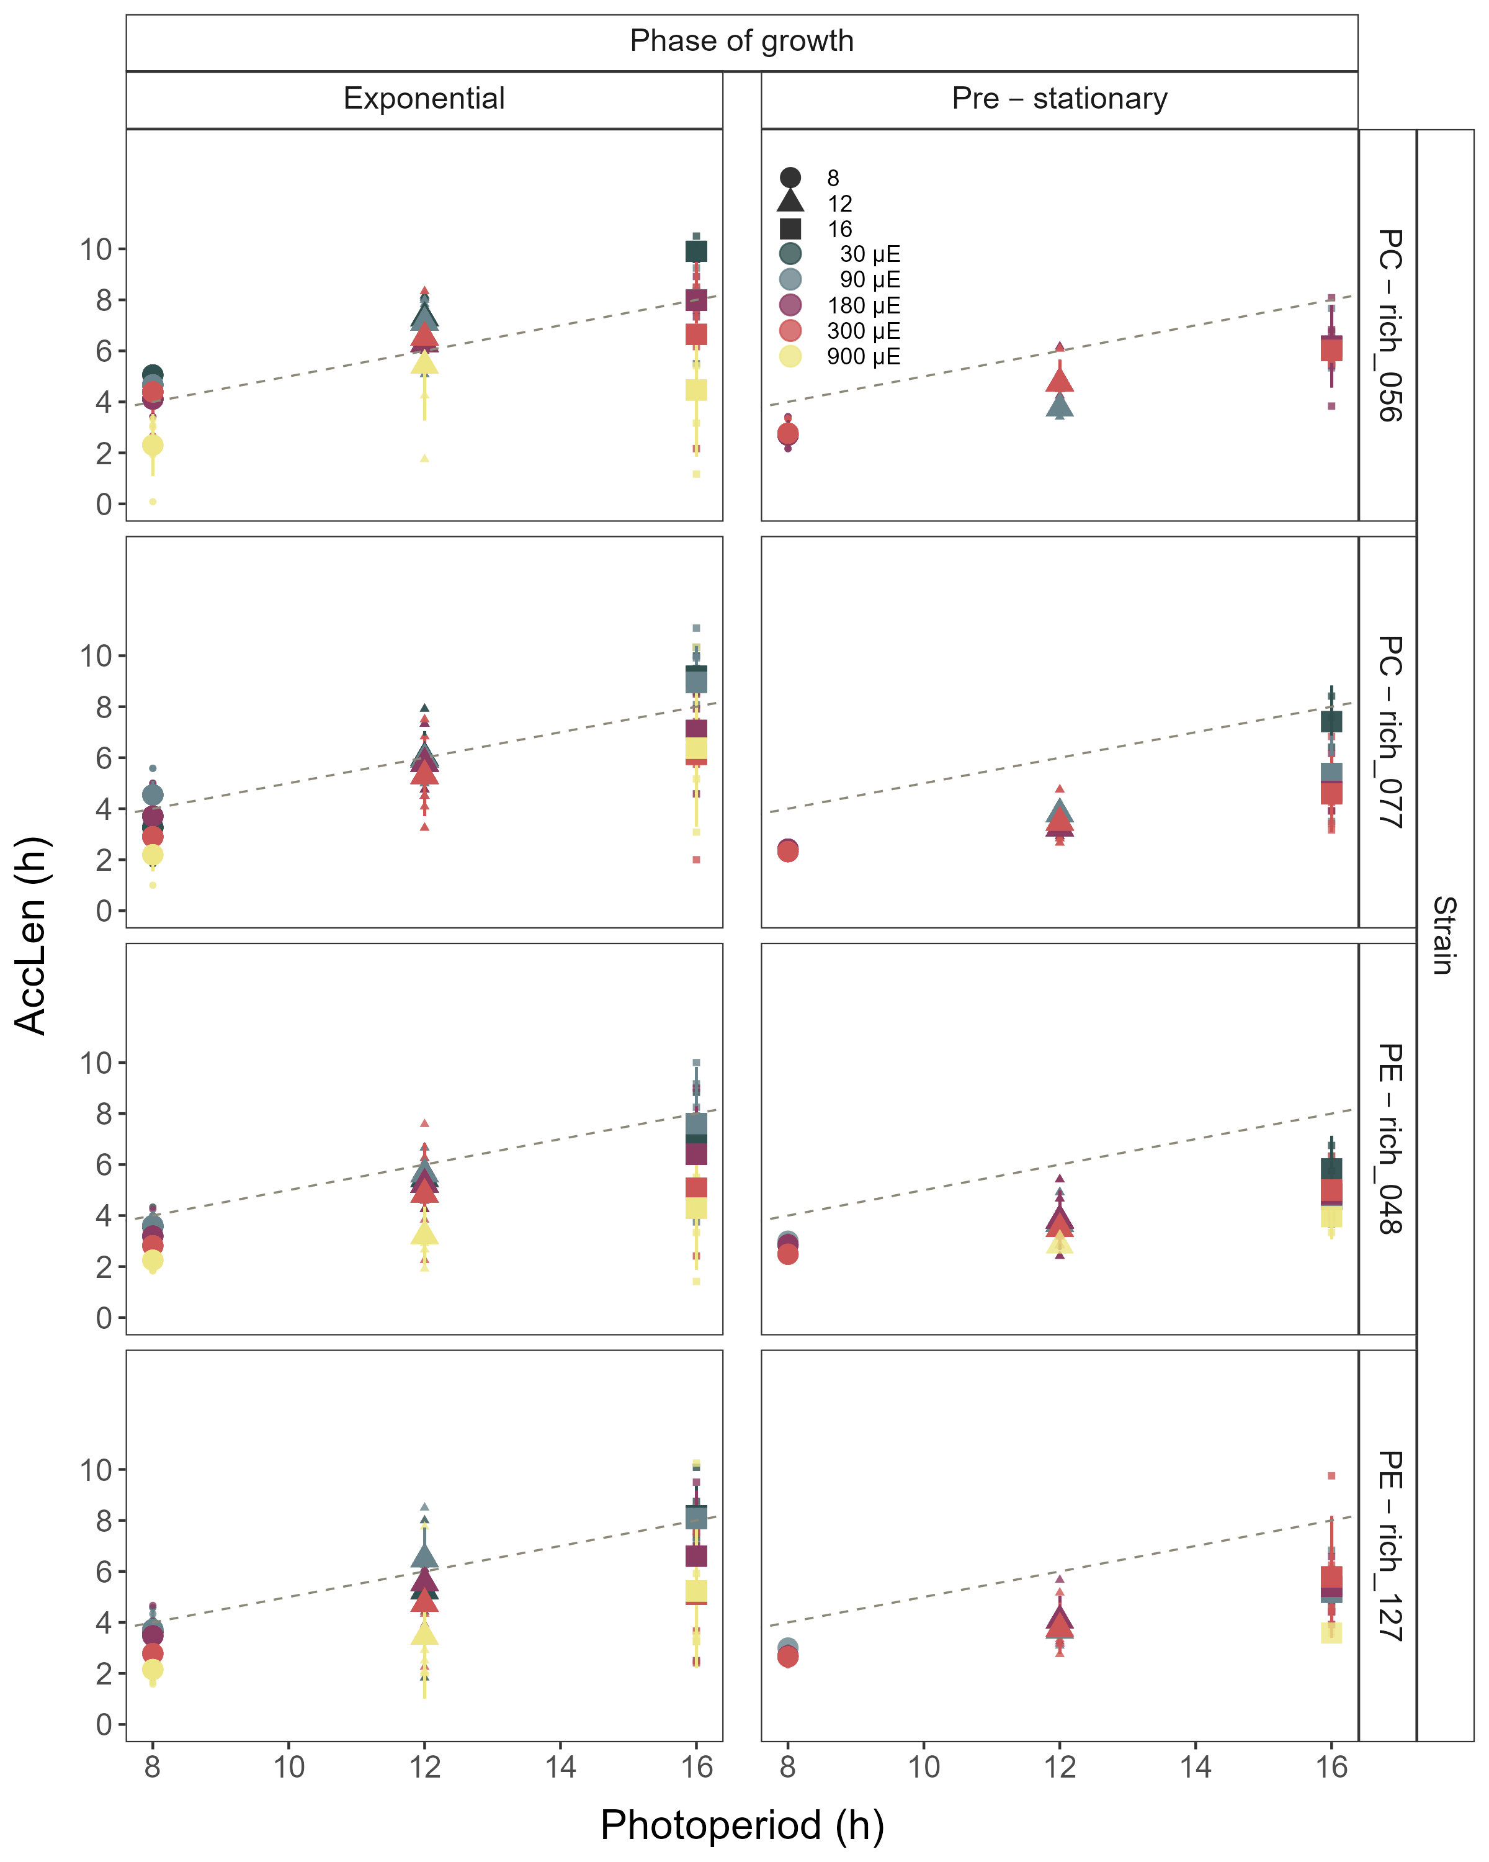

Figure 3: Hours of photoperiod to reach maximum hourly growth increment (AccLen), for two PhycoCyanin(PC)-rich cultures (056, 077) and two PhycoErythrin(PE)-rich cultures (048, 127) (Culture Collection of Baltic Algae) of *Synechococcus* sp. grown at 30, 90, 180, 300, or 900 peak PAR µmol photons m−2s−1; and photoperiods of 8, 12, or 16 h. The diagonal dashed lines indicate the time (h) to reach the maximum light during the day. Figure represents all data (small symbols) and means (big symbols) for n = 0-5 days from exponential phase, or from pre-stationary growth phase.

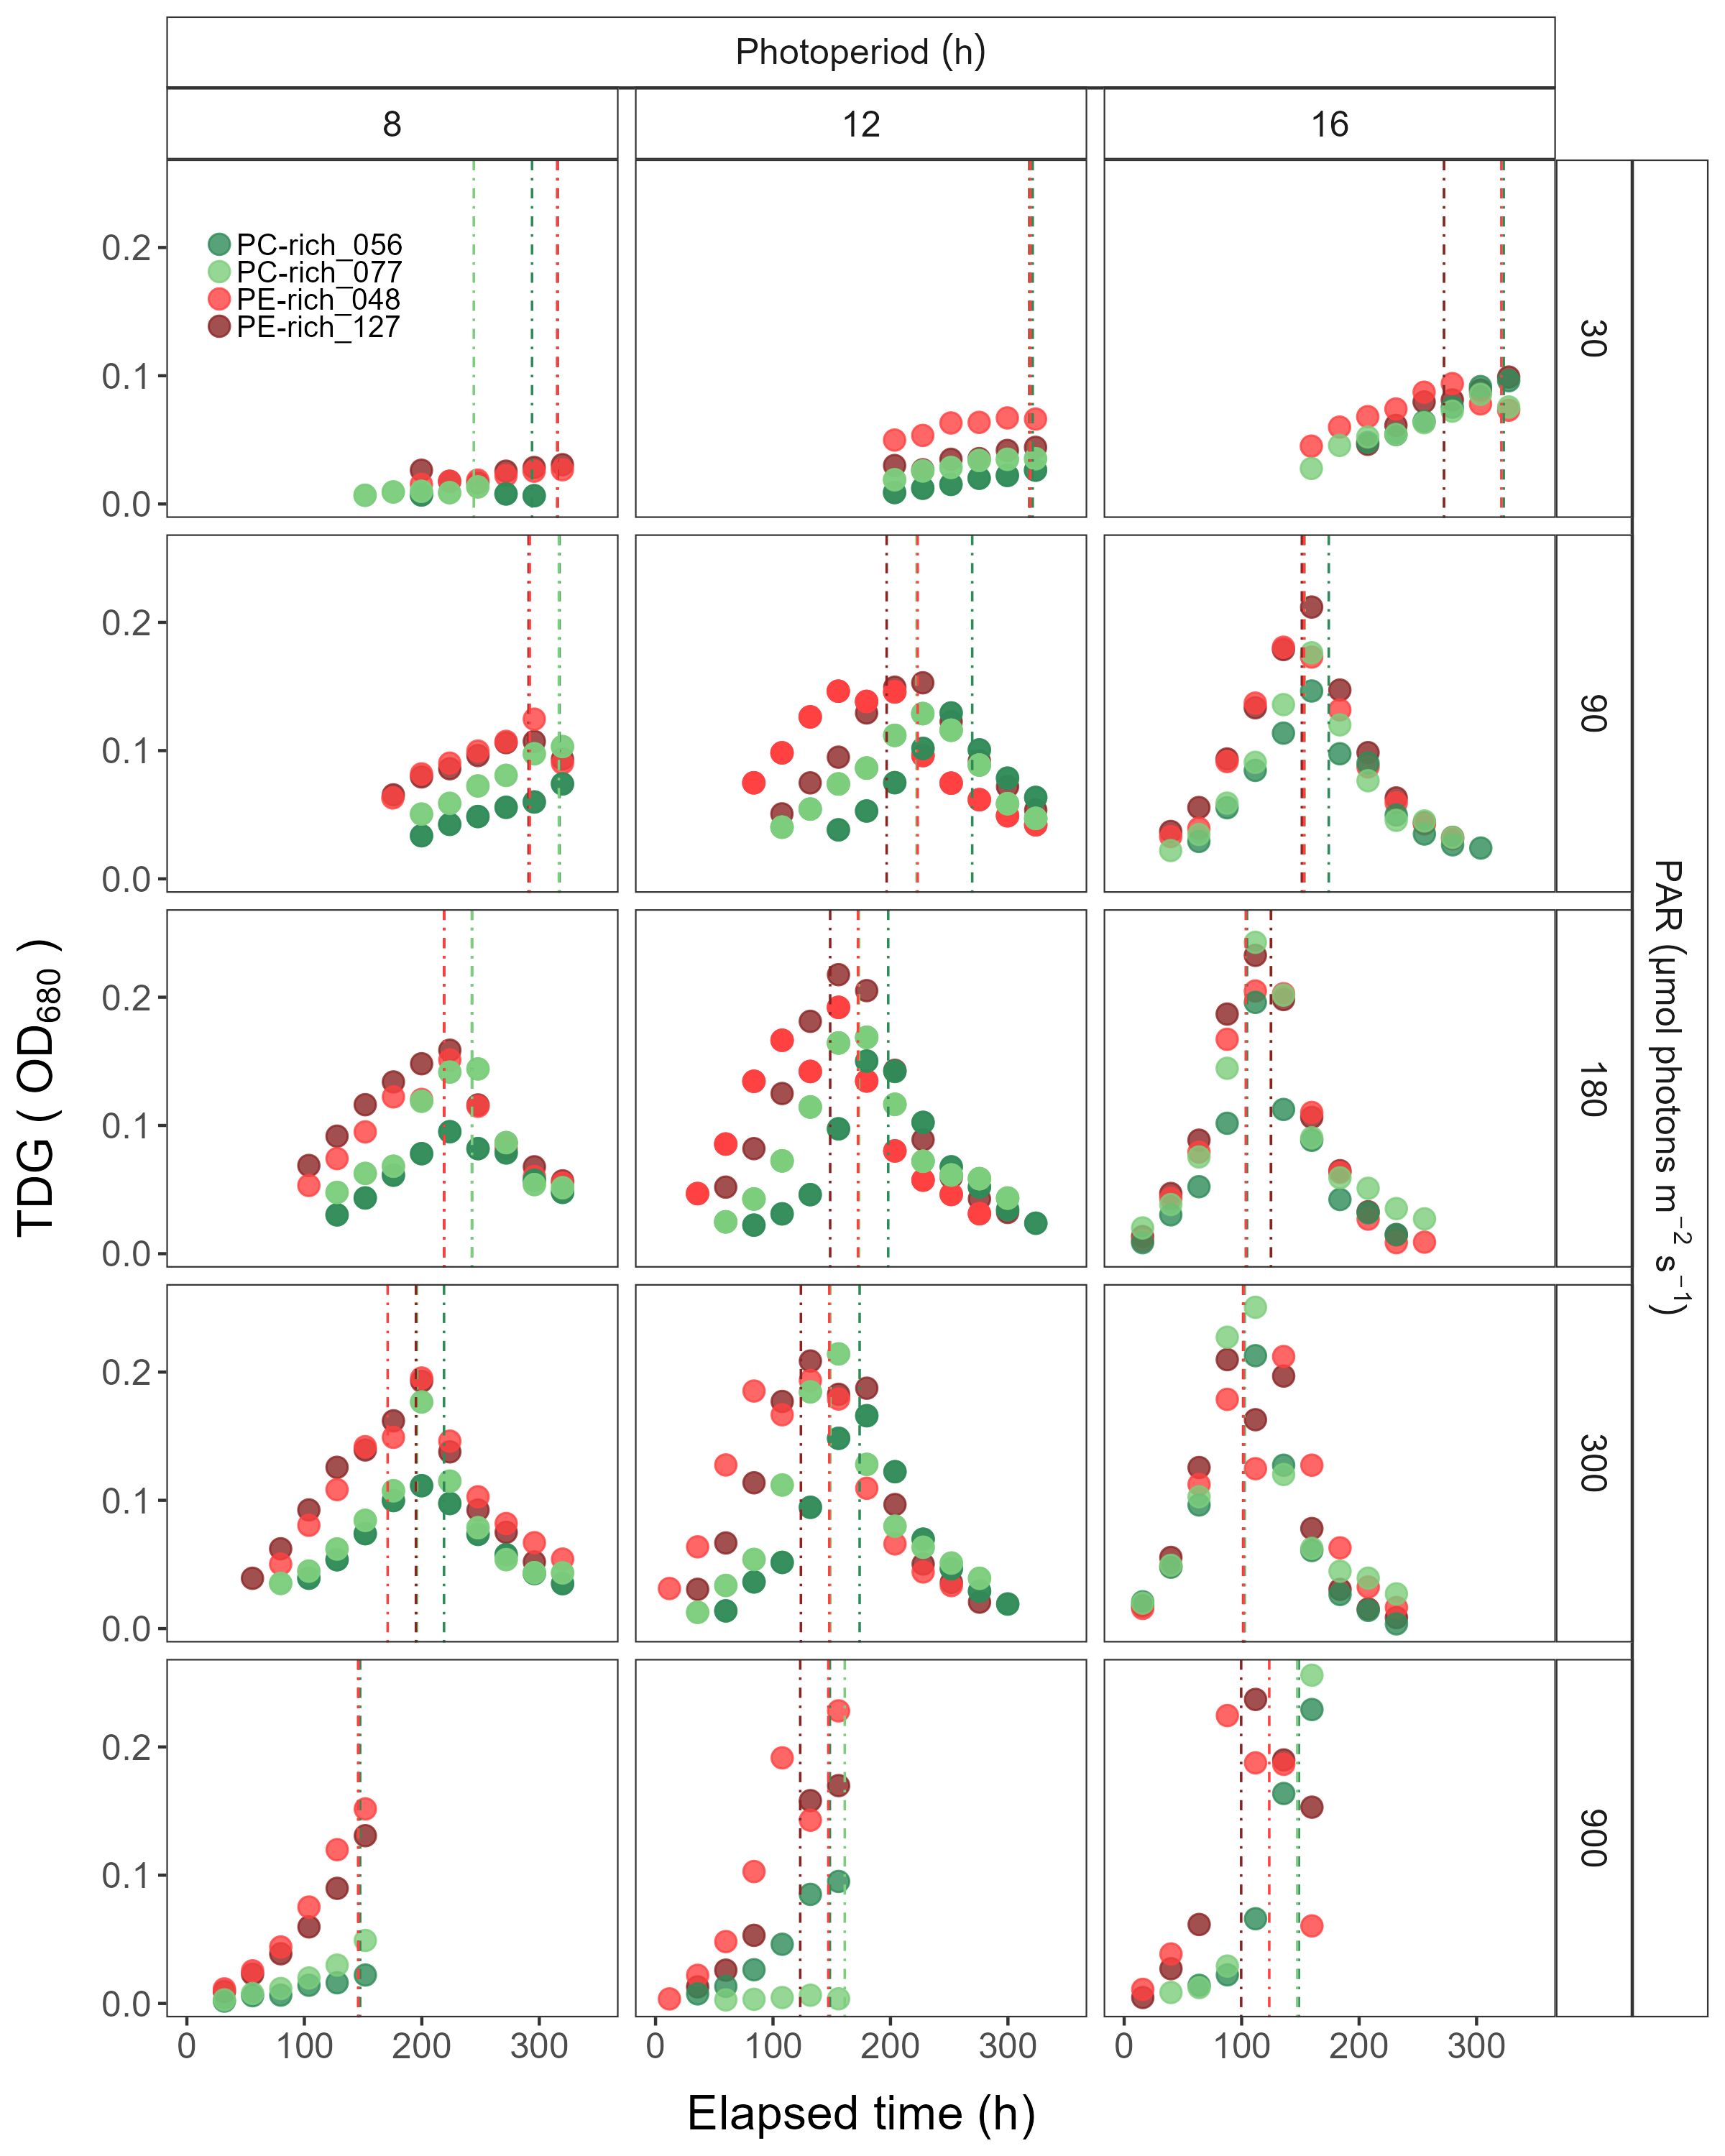

Figure 4: Changes of TDG (tracked as daily change in OD680 increment) of two PhycoCyanin(PC)-rich cultures (056, 077) and two PhycoErythrin(PE)-rich cultures (048, 127) (Culture Collection of Baltic Algae) of *Synechococcus* sp. grown at 30, 90, 180, 300, or 900 peak PAR µmol photons m−2s−1; and photoperiods of 8, 12, or 16 h. The vertical lines represent the time when the strains reached their maximum absolute hourly growth (tMaxAG).

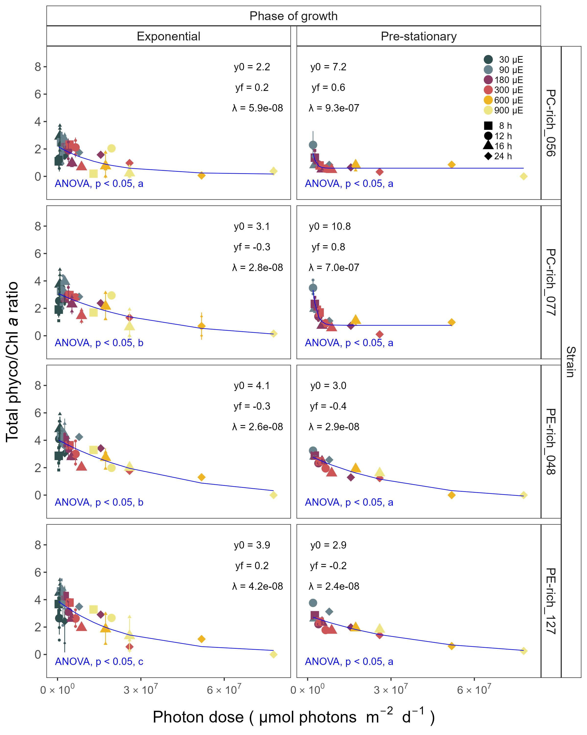

Figure 5: Changes of total Phyco/Chl *a* ratio of two PhycoCyanin(PC)-rich cultures (056, 077) and two PhycoErythrin(PE)-rich cultures (048, 127) (Culture Collection of Baltic Algae) of *Synechococcus* sp. grown at 30, 90, 180, 300, 600, or 900 peak PAR µmol photons m−2s−1; and photoperiods of 8, 12, 16, or 24 h. Figure represents all data (small symbols) and means (big symbols) from exponential phase, or from pre-stationary growth phase. Blue solid line shows single phase exponential decay fit of pooled data; fit parameters are presented. Different lowercase letters indicate significant differences between the fit models for strains for a given phase of growth (ANOVA; *p* < 0.05).

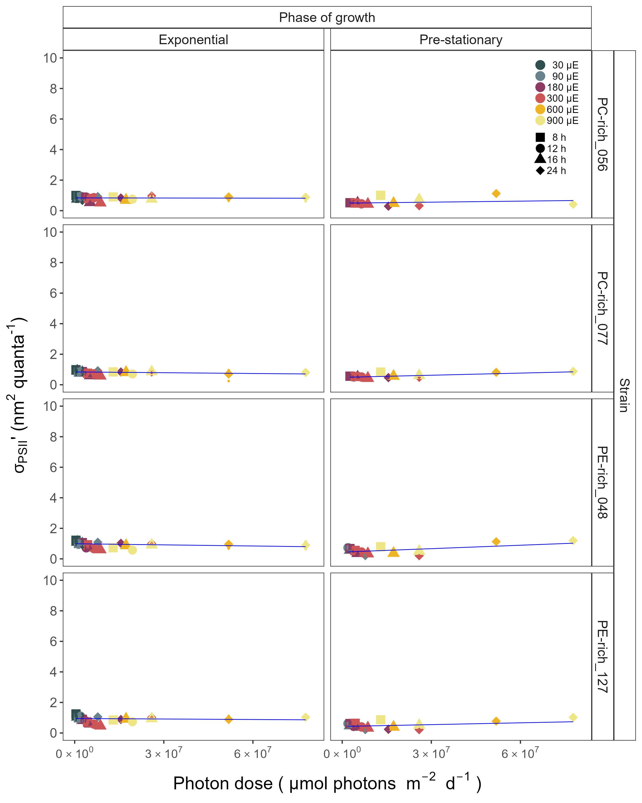

Figure 6: Effective absorption cross section of PSII (σPSII’; nm2 quanta-1) measured under diel peak PAR growth light under Ex445 nm (blue) excitation in two PhycoCyanin(PC)-rich cultures (056, 077) and two PhycoErythrin(PE)-rich cultures (048, 127) (Culture Collection of Baltic Algae) of *Synechococcus* sp. grown at 30, 90, 180, 300, 600, or 900 peak PAR µmol photons m−2s−1; and photoperiods of 8, 12, 16, or 24 h. Figure represents all data (small symbols) and means (big symbols) from exponential phase, or from pre-stationary growth phase. Blue solid line shows linear model fit.